# Assignment -3

Python Programming

|  |  |
| --- | --- |
| Assignment Date | 02 October 2022 |
| Student Name | VIDHYA V |
| Student Roll Number | 718019L148 |
| Maximum Marks | 2 Marks |

# Question-1:

Write a python code for led blinking in raspberry pi SOLUTION:

import RPi.GPIO as GPIO # Import Raspberry Pi GPIO library

from time import sleep # Import the sleep function from the time module

GPIO.setwarnings(False) # Ignore warning for now GPIO.setmode(GPIO.BOARD) # Use physical pin numbering

GPIO.setup(8, GPIO.OUT, initial=GPIO.LOW) # Set pin 8 to be an output pin and set initial value to low (off)

while True: # Run forever GPIO.output(8, GPIO.HIGH) # Turn on sleep(1) # Sleep for 1 second GPIO.output(8, GPIO.LOW) # Turn off sleep(1) # Sleep for 1 second

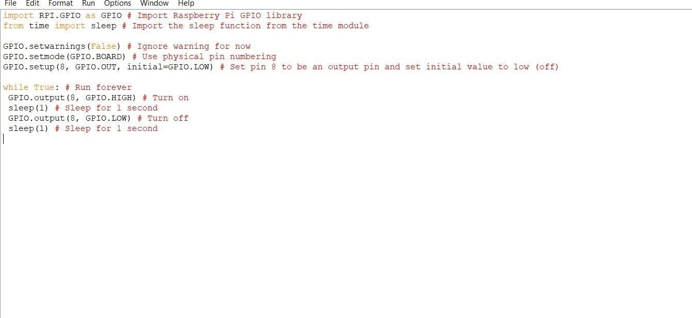

# Question-2:

Write a python code for traffic light in raspberry pi SOLUTION:

from gpiozero import Button, TrafficLights, Buzzer from time import sleep

buzzer = Buzzer(15) button = Button(21)

lights = TrafficLights(25, 8, 7)

while True:

button.wait_for_press() buzzer.on() light.green.on() sleep(1) lights.amber.on() sleep(1)

lights.red.on() sleep(1) lights.off() buzzer.off()

